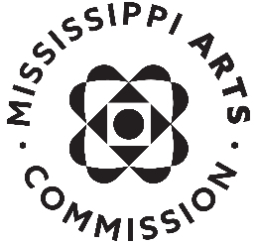

Sample News Release

For Immediate Release

Contact: (your name, title)
(your phone and email)
Date:

(Your name/organization) Receives Mississippi Arts Commission Grant

JACKSON, MISS. – (Today’s date) – (Your name/organization) of (city where you/organization is based) has been awarded a ($ amount) grant from the Mississippi Arts Commission. This grant is a portion of the more than $1.75 million in grants MAC awarded in Fiscal Year 2024 and will be used to (do what?).

“With the additional funds provided to MAC this fiscal year, we are able to fund 37 more grants that are providing an economic impact for Mississippi communities, the arts, and education throughout the state,” said David Lewis, executive director for the Mississippi Arts Commission. “We are grateful for the support from the Mississippi Legislature and elected officials who helped prioritize the arts in Mississippi.”

(insert short paragraph about your work and accomplishments)

MAC’s annual grant funds come from the National Endowment for the Arts and the Mississippi State Legislature. Awards were made in 104 Mississippi House of Representatives districts and 60 state Senate districts.

The Mississippi Arts Commission is a state agency serving more than two million people through grants and special initiatives that enhance communities, assist artists and arts organizations, promote arts education, and celebrate Mississippi’s cultural heritage. MAC is funded by the Mississippi Legislature, the National Endowment for the Arts, the Mississippi Endowment for the Arts at the Community Foundation for Mississippi, and other private sources. For more information, visit www.arts.ms.gov.

For information about the Mississippi Arts Commission, please contact Ellie Banks, Communications Director, 601-359-6546 or ebanks@arts.ms.gov.

###

