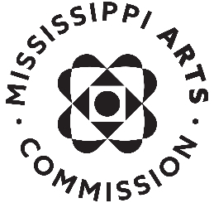

Sample News Release for Organizations

For Immediate Release

Contact: (your name, title)
(your phone and email)

(Your organization) Receives Mississippi Arts Commission Grant

JACKSON, MISS. – (Today’s date) – (Your organization) of (city where organization is based) has been awarded a ($ amount) grant from the Mississippi Arts Commission. This grant is a portion of the more than $1.6 million in grants MAC awarded in Fiscal Year 2023 and will be used to (do what?). The grants are made possible by continued funding from the Mississippi State Legislature and the National Endowment for the Arts.

“MAC is honored to support the exceptional work of arts organizations who cultivate the culture we, as Mississippians, have become known for producing,” said David Lewis, executive director of MAC. “These funds will help organizations build upon their successes for arts-based programming within their community. MAC awards annual grants to organizations in nearly every area of the state, helping broaden the reach of arts to serve the state’s diverse population.”

(insert short paragraph about your work and accomplishments)

The Mississippi Arts Commission is a state agency serving more than two million people through grants and special initiatives that enhance communities, assist artists and arts organizations, promote arts education and celebrate Mississippi’s cultural heritage. MAC is funded by the Mississippi Legislature, the National Endowment for the Arts, the Mississippi Endowment for the Arts at the Community Foundation for Mississippi and other private sources. For more information, visit www.arts.ms.gov.

For information about the Mississippi Arts Commission, please contact Ellie Banks, Communications Director, 601-359-6546 or ebanks@arts.ms.gov.

###

